How to Install Nginx and PHP 7.3 on Debian 10
July 20, 2019 3 min read
7,422

author:
David

How to Install Nginx and PHP 7.3 on Debian 10
Just recently on July 6th, 2019, Debian 10 buster released, and with it came a lot of features. This tutorial will show you how you can install Nginx mainline version on Debian 10 for optimal performance.

Step 1: Install Nginx
Firstly we need to install the prerequisites.
sudo apt install curl gnupg2 ca-certificates lsb-release
Then we need to add the Nginx mainline package to our repository so that when we run apt install nginx, we will download the mainline version instead of the old stable version.
echo "deb http://nginx.org/packages/mainline/debian `lsb_release -cs` nginx" \
| sudo tee /etc/apt/sources.list.d/nginx.list
Optionally, if you would rather want to use the older and slower stable version of Nginx you can do so by running: (Remember that you should only run one of the following)
echo "deb http://nginx.org/packages/mainline/debian `lsb_release -cs` nginx" \
| sudo tee /etc/apt/sources.list.d/nginx.list
Next we need to download the signing key so that we can verify its authenticity
curl -fsSL https://nginx.org/keys/nginx_signing.key | sudo apt-key add -
If it prints out OK! then you are good to go!
Now that we have downloaded & verified its authnicity lets install it!
sudo apt update
sudo apt install nginx
That’s it! You have now installed the latest release of Nginx on Debian 10. You should now start it!
sudo systemctl start nginx.service
Don’t forget to make it automaticly start on system boot as well.
sudo systemctl enable nginx.service
Visit your server’s IP address in your webbrowser. You should now see something along these lines if it is working correctly.
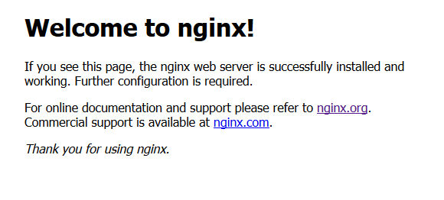

Step 2: Install PHP 7.3
To add the repositories for PHP:
sudo apt-get install software-properties-common
Run this to download your added repositories:
sudo apt update
We can now install PHP now that we have all of the required repositories.
sudo apt install php7.3-fpm php7.3-common php7.3-mysql php7.3-gmp php7.3-curl php7.3-intl php7.3-mbstring php7.3-xmlrpc php7.3-gd php7.3-xml php7.3-cli php7.3-zip php7.3-soap php7.3-imap
It is recommended to raise the memory limit to improve the overall performance. Your PHP configuration is located in/etc/php/7.3/fpm/php.ini.
sudo nano /etc/php/7.3/fpm/php.ini
Press + and search for memory_limit.
Replace it with memory_limit = 256
Save & exit by pressing + followed by

Step 3: Configure Nginx
Add nginx to www-data group
sudo usermod -a -G www-data nginx
Change owner of directory to www-data
sudo chown -R www-data /usr/share/nginx/html
Go into your default.conf file
sudo nano /etc/nginx/conf.d/default.conf
Replace your existing configuration file with the one below
server {
listen 80;
server_name localhost;

root /usr/share/nginx/html;
index index.php index.html index.htm;

location / {
if ($request_uri ~ ^/(.*)\.html$) {
return 302 /$1;
}
}

error_page 500 502 503 504 /50x.html;
location = /50x.html {
root /usr/share/nginx/html;
}
location ~ \.php$ {
fastcgi_split_path_info ^(.+\.php)(/.+)$;
fastcgi_pass unix:/var/run/php/php7.3-fpm.sock;
fastcgi_index index.php;
fastcgi_param SCRIPT_FILENAME $document_root$fastcgi_script_name;
include fastcgi_params;
}

}
Save & exit by pressing + followed by
Now restart your Nginx:
service nginx restart
That’s it! However, you may now test to see if php works
nano /usr/share/nginx/html/phpinfo.php
Add the following lines
<?php

phpinfo();

?>
Save & exit by pressing + followed by
Now go to YOURSERVERIP/phpinfo.php in your web browser. You should see something along these lines
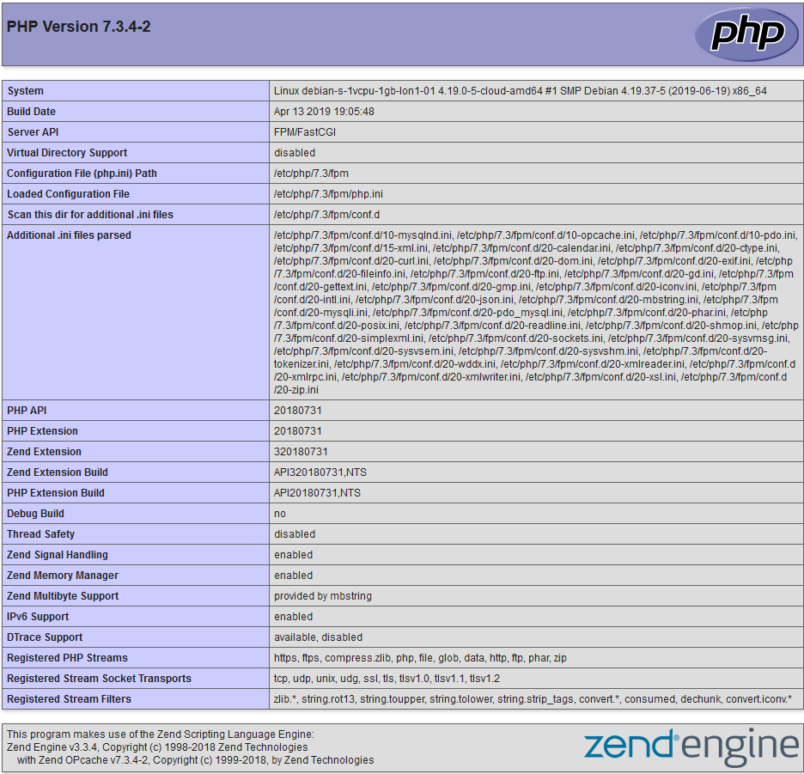
That’s it! Now you know how to install Nginx and PHP 7.3 on Debian 10. You can now go ahead and install anything you want, such as WordPress. Don’t forget to try out our VPS too! Our servers are located in stockholm, so if you’re from Sweden feel free to check out our Swedish site too, and grab yourself a Stockholm VPS.
https://hostup.org/blog/how-to-install-nginx-and-php-7-3-on-debian-10/

How to Install Nginx and PHP 8 on Debian 10
January 28, 2021 3 min read

Contents
- Step 1: Install Nginx
- Step 2: Install PHP 8
- Step 3: Configure Nginx
author:
David

How to Install Nginx and PHP 8 on Debian 10
PHP 8 is the latest PHP version released. This tutorial will show you how you can install Nginx mainline version on Debian 10 for optimal performance as well as the newest version of PHP, currently 8.0.

Step 1: Install Nginx
Firstly we need to install the prerequisites.
sudo apt install curl gnupg2 ca-certificates lsb-release
Then we need to add the Nginx mainline package to our repository so that when we run apt install nginx, we will download the mainline version instead of the old stable version.
echo "deb http://nginx.org/packages/mainline/debian `lsb_release -cs` nginx" \
| sudo tee /etc/apt/sources.list.d/nginx.list
Optionally, if you would rather want to use the older and slower stable version of Nginx you can do so by running: (Remember that you should only run one of the following)
echo "deb http://nginx.org/packages/mainline/debian `lsb_release -cs` nginx" \
| sudo tee /etc/apt/sources.list.d/nginx.list
Next we need to download the signing key so that we can verify its authenticity
curl -fsSL https://nginx.org/keys/nginx_signing.key | sudo apt-key add -
If it prints out OK! then you are good to go!
Now that we have downloaded & verified its authnicity lets install it!
sudo apt update
sudo apt install nginx
That’s it! You have now installed the latest release of Nginx on Debian 10. You should now start it!
sudo systemctl start nginx.service
Don’t forget to make it automaticly start on system boot as well.
sudo systemctl enable nginx.service
Visit your server’s IP address in your webbrowser. You should now see something along these lines if it is working correctly.

Step 2: Install PHP 8
To add the repositories for PHP:
sudo apt-get install software-properties-common
Since PHP 7.4 didn’t come with Debian 10 it is required to add the following repository
sudo add-apt-repository ppa:ondrej/php
Run this to download your added repositories:
sudo apt update
We can now install PHP now that we have all of the required repositories.
sudo apt install php8.0-fpm php8.0-common php8.0-mysql php8.0-gmp php8.0-curl php8.0-intl php8.0-mbstring php8.0-xmlrpc php8.0-gd php8.0-xml php8.0-cli php8.0-zip php8.0-soap php8.0-imap
It is recommended to raise the memory limit to improve the overall performance. Your PHP configuration is located in/etc/php/8.9/fpm/php.ini.
sudo nano /etc/php/8.0/fpm/php.ini
Press + and search for memory_limit.
Replace it with memory_limit = 256
Save & exit by pressing + followed by

Step 3: Configure Nginx
Add nginx to www-data group
sudo usermod -a -G www-data nginx
Change owner of directory to www-data
sudo chown -R www-data /usr/share/nginx/html
Next up we need to replace our existing default.conf file for Nginx. To do this easily run the following commands:
sudo rm /etc/nginx/conf.d/default.conf
sudo touch /etc/nginx/conf.d/default.conf
Go into your default.conf file
sudo nano /etc/nginx/conf.d/default.conf
Paste the following in the configuration file
server {
listen 80;
server_name localhost;

root /usr/share/nginx/html;
index index.php index.html index.htm;

location / {
if ($request_uri ~ ^/(.*)\.html$) {
return 302 /$1;
}
}

error_page 500 502 503 504 /50x.html;
location = /50x.html {
root /usr/share/nginx/html;
}
location ~ \.php$ {
fastcgi_split_path_info ^(.+\.php)(/.+)$;
fastcgi_pass unix:/var/run/php/php8.0-fpm.sock;
fastcgi_index index.php;
fastcgi_param SCRIPT_FILENAME $document_root$fastcgi_script_name;
include fastcgi_params;
}

}
Save & exit by pressing + followed by
Now restart your Nginx:
service nginx restart
That’s it! However, you may now test to see if php works
nano /usr/share/nginx/html/phpinfo.php
Add the following lines
<?php

phpinfo();

?>
Save & exit by pressing + followed by
Now go to YOURSERVERIP/phpinfo.php in your web browser. You should see something along these lines
That’s it! Now you know how to install Nginx and PHP 7.4 on Debian 10.
https://hostup.org/blog/how-to-install-nginx-and-php-8-on-debian-10/

Install Nginx with PHP and MySQL (LEMP) plus SSL on Debian 10

LEMP is an acronym that stands for the following software stack: Linux kernel, Nginx web server, MariaDB database (or MySQL), and the PHP server-side programming language. This software is widely used on servers on the Internet today to provide dynamic websites or interactive web applications.
Nginx is a modern and resource-efficient web server that is actively developed and is the second most used web server on the Internet after the Apache HTTP server. It is particularly fast because it uses an asynchronous, event-driven approach to processing requests.
This tutorial shows you how to install and configure the LEMP stack (Nginx with MariaDB and PHP 7) on the latest version of Debian 10.

REQUIREMENTS
- The latest version of the Debian 10 operating system, which can be obtained from the following link https://www.debian.org/CD/http-ftp/, installed from scratch on a VPS, virtual machine or directly on a self-dedicated machine.
- Direct access to the server’s console or a remote SSH connection.
- A network interface configured with a static IP address for the machine
- A registered public domain name with A and CNAME (www) DNS records configured on the name server side. In this guide, we use the example.com domain as an example.

Step 1: Initial Configuration
The first step is to log in with root or with a user with root privileges in your system and update Debian 10 components (kernel upgrades, package updates, and security patches) by issuing the following commands.
sudo apt update
sudo apt upgrade
sudo apt dist-upgrade
Next, you make sure you add a descriptive name for your machine hostname by running the below command. Subsequently, you should restart the system in order to apply the new hostname accordingly.
sudo hostnamectl set-hostname hostname.yourdomain.com
sudo init 6
Next, go ahead and install net-tools wget, curl and bash-completion utilities in order to use them later to easily administer your Debian server.
sudo apt install net-tools sudo wget curl bash-completion

Step 2: Install the Nginx Web Server
Nginx is a modern and resources efficient web server used to display web pages to visitors on the internet. Install Nginx webserver from Debian 10 repository by running the below command in your server’s console.
sudo apt-get install nginx
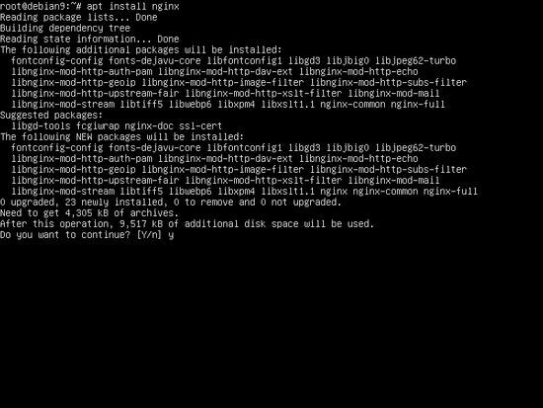

As shown in the above image the apt package manager will check additional dependencies for the package and ask you if you agree to continue with the installation process. Answer with yes (y) in order to install Nginx.
Next, run netstat command in order to display network sockets on your system and verify if nginx daemon is listening on port 80/TCP. Alternatively, you might want to issue systemctl command in order to check the status of nginx daemon as illustrated in the below image.
sudo netstat -tlp
sudo netstat –tlpn
sudo systemctl status nginx.service
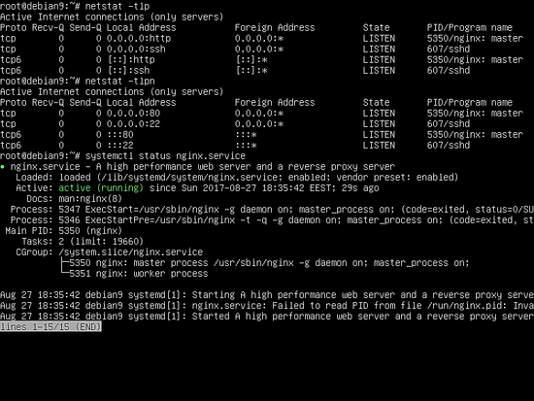
Once the nginx server is up and running in your system, issue ifconfig command in order to display network interfaces information and list the IP addresses of your machine. Then, open a browser and visit Nginx default web page via HTTP protocol by adding the IP address in your browser. The message “Wellcome to Nginx!” should be displayed in your browser window.
http://www.example.comAdvertisement

or
http://192.168.0.100
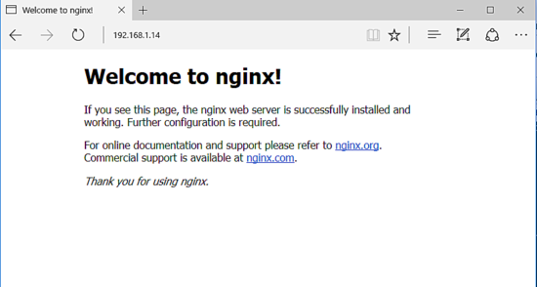

Step 3: Activate Nginx HTTP/2.0 Protocol
By default, the latest versions of the Nginx binaries provided by the Debian 10 repositories are built with the HTTP/2.0 protocol. HTTP/2.0 is integrated with TSL/SSL protocols and can improve web page loading speed via secured transactions.
All modern browsers, such as Chrome or Firefox, should support this protocol by default. However, note that Microsoft Internet Explorer and Microsoft Edge browsers cannot yet parse the http2 protocol.
To enable the HTTP/2.0 protocol in Nginx on Debian 10, you need to make some changes to the default Nginx configuration file or create a new configuration file and add the TLS code block for 443 servers. To accomplish this, first create a backup of the default Nginx sites-available configuration by running the following command. Confirm that the backup was successful by listing the contents of the sites-available directory.
sudo cp /etc/nginx/sites-available/default{,.backup}
ls /etc/nginx/sites-available/
Next, create an Nginx TLS configuration file using a text editor and add the following content.
sudo nano /etc/nginx/sites-available/default-ssl
default-ssl file excerpt:
server {
listen 443 ssl http2 default_server;
listen [::]:443 ssl http2 default_server;
#server_name www.domain.tld;
server_name _;

root /var/www/html;

access_log /var/log/nginx/access.log;
error_log /var/log/nginx/error.log;

#SSL Certificates
ssl_certificate "/etc/nginx/ssl/cert.pem";
ssl_certificate_key "/etc/nginx/ssl/privekey.pem";
ssl_dhparam /etc/nginx/ssl/dhparam.pem;

ssl_protocols TLSv1 TLSv1.1 TLSv1.2;
#ssl_ciphers EECDH+CHACHA20:EECDH+AES128:RSA+AES128:EECDH+AES256:RSA+AES256:EECDH+3DES:RSA+3DES:!MD5;

ssl_session_cache shared:SSL:1m;
ssl_session_timeout 10m;
ssl_ciphers HIGH:!aNULL:!MD5;
ssl_prefer_server_ciphers on;

add_header Strict-Transport-Security "max-age=31536000;
#includeSubDomains" always;

location / {
index index.php index.html index.htm;
try_files $uri $uri/ /index.php?$args $uri/ =404;
}

set $cache_uri $request_uri;

location ~ /.well-known {
allow all;
}
location ~ \.php$ {
include snippets/fastcgi-php.conf;
#
# # With php-fpm (or other unix sockets):
fastcgi_pass unix:/var/run/php/php7.0-fpm.sock;
# # With php-cgi (or other tcp sockets):
# fastcgi_pass 127.0.0.1:9000;
}

# deny access to .htaccess files, if Apache's document root
# concurs with nginx's one
#
#location ~ /\.ht {
# deny all;
#}
}

The statement that enables the use of HTTP/2.0 protocol is represented by the word http2 from the below line.
listen 443 ssl http2 default_server;
In case your visitor’s browsers don’t support HTTP2 protocol, remove the http2 word from your server configurations in order to disable the protocol and restart nginx service to apply changes.
In case you have a registered domain or you use virtual hosting based on IP addresses you should add your domain name or IP address after the server_name directive as shown in the below example.
server_name www.example.com example.com;
Once you finished editing Nginx default configuration file with the above settings

Configure SSL in Nginx
In the above TSL configuration file of nginx, we have specified the path for the TLS certificate and key. Since we have not yet installed the keys in your system, enter the following command to generate the self-signed SSL certificate file and key. During the generation of the SSL certificate, you will be asked a series of questions. Enter the two-digit code for your country, state, or province, the name of your city, the name of your organization, the name of your organization’s unit, the Common Name of your server, and a valid email address. You should make sure to set the Common Name so that it matches the FQDN record of your computer from the DNS server or the IP address of your server used to access the website. The certificate and key are stored in a new directory under the nginx directory named ssl, as shown in the following screenshot.
sudo mkdir /etc/nginx/ssl
sudo openssl req -x509 -nodes -days 365 -newkey rsa:2048 -keyout /etc/nginx/ssl/privekey.pem -out /etc/nginx/ssl/cert.pem
ls /etc/nginx/ssl/
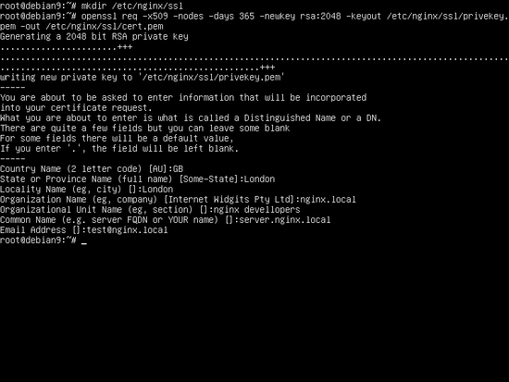
Also, generate a new strong Diffie-Hellman cipher, which can be found in the above configuration file on ssl_dhparam statement line, by issuing the below command:
sudo openssl dhparam -out /etc/nginx/ssl/dhparam.pem 2048
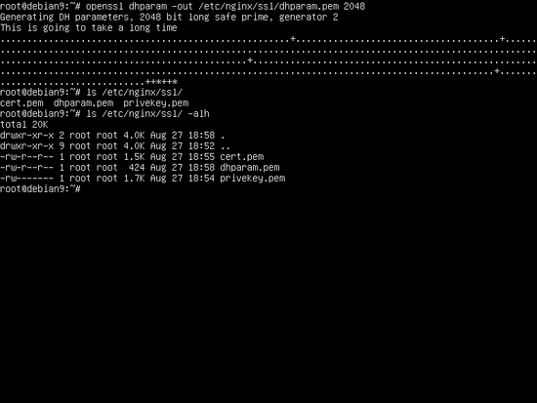
Finally, after you’ve generated the Diffie-Hellman key, activate the TLS configuration file by creating a symbolic link for default-ssl configuration file from sites-available directory to sites-enabled directory by issuing the following command.
ln -s /etc/nginx/sites-available/default-ssl /etc/nginx/sites-enabled/
Next, test Nginx configuration file for syntax errors and, if everything is ok, restart Nginx daemon in order to apply all changes by running the below commands.
sudo nginx -t
sudo systemctl restart nginx.service

Check if SSL Configuration succeeded
In order to confirm if Nginx web server is binding on SSL port, issue netstat command and check if port 443 is displayed in listening mode.
netstat -tlpn | grep nginx
The below screenshot illustrated the above steps.
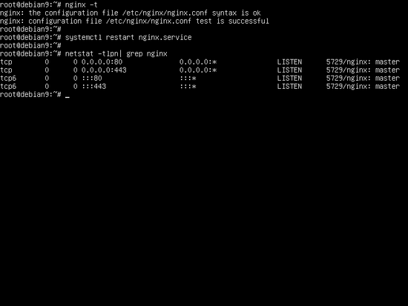
Then, navigate to your domain name or your server’s IP address via HTTP protocol from a browser to display nginx default page. Because you’re using self-signed certificates, an error should be displayed in your browser. Confirm the error in order to pass to the nginx default main page.
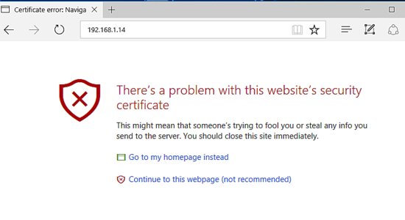
In case Nginx doesn’t provide a default index.html page in webroot directory, issue the following command to create the index page.
echo "test page" | tee /var/www/html/index.html
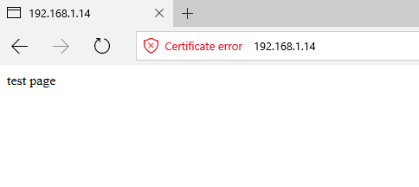
In order to confirm the presence of HTTP/2.0 protocol advertised by Nginx, issue the below command. Look for h2 word in protocols advertised by the server.
openssl s_client -connect localhost:443 -nextprotoneg ''
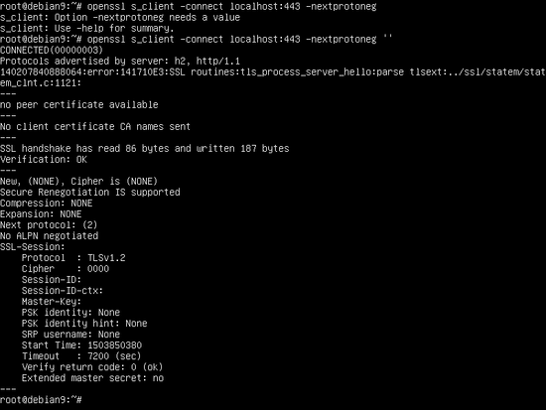
You can also visualize the state of the connection and check if the http2 protocol is advertised by Nginx from the Chrome browser by pressing F12 function key and request the page. In order to show the protocol used by the request, go to the Network tab, right-click on the Type menu and check Protocol filed. HTTP2 protocol should be displayed as h2 in the current protocol column, as illustrated in the below screenshot.
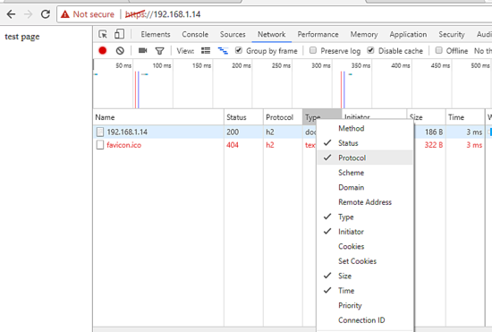

Step 4: Install PHP 7
Nginx web server can serve dynamic web content with the help of PHP programming language interpreter via PHP FastCGI process manager to which Nginx passes the requests for processing. FastCGI process manager can be obtained by installing the php-fpm pre-compiled package offered by Debian 9 official repositories.
In order to install php-fpm process manager and PHP7.0 interpreter in the system alongside with the additional packages that will allow PHP to communicate with Nginx web server, issue the below command on your server console:
sudo apt install php7.3 php7.3-fpm php7.3-curl php7.3-gd

Start PHP-FPM
Once the PHP 7.3 interpreter has been successfully installed on your system, start and check php7.3-fpm daemon by issuing the below command:
sudo systemctl start php7.3-fpm
sudo systemctl status php7.3-fpm
In the above TLS configuration file of Nginx, we’ve already added the block configurations for PHP FastCGI process manager in order to serve dynamic content. The block of code that enables Nginx to use PHP interpreter is shown in the below excerpt, so no steps are needed further to modify Nginx TSL configuration file. The hashtag # sign from the beginning of the lines in the below screenshot are comments. Commented lines from configuration files are ignored by default by Nginx web server.
location ~ \.php$ {
include snippets/fastcgi-php.conf;
fastcgi_pass unix:/run/php/php7.3-fpm.sock;
}

Test PHP Configuration
In order to test and validate if Nginx can correctly pass php files to PHP processor, create a PHP info.php test configuration file by issuing the below command
sudo su -c 'echo "<?php phpinfo(); ?>" > /var/www/html/info.php'
Then, visit php info page in your web browser by navigating to your server’s domain name or public IP address followed by /info.php as shown in the below image.
https://www.example.com/info.php
or
http://192.168.0.100/info.php
You can also check if HTTP/2.0 protocol is advertised by the server by searching for the line $_SERVER[‘SERVER_PROTOCOL’] on PHP Variables.
To install other PHP7.3 modules, run the apt search php7.3 command to find a specific PHP module and install it. If you are planning to install a Content Management System, such as WordPress, then install these extra modules:
sudo apt install php7.3-mcrypt php7.3-mbstring
However, the newly installed PHP modules are not enabled by default on your system. In order to activate them, restart the PHP-FPM service.
sudo systemctl restart php7.3-fpm.service

Step 5: Install MariaDB Database
Finally, the last piece of the LAMP stack puzzle is missing in the database. The MariaDB database LEMP component is used to store records in tables and columns. It will dynamically manage the data of a web application. To install the MariaDB, run the following command in your server’s console. Then, restart the PHP FPM daemon to enable the PHP-MySQL module that is required to access the database.
sudo apt install mariadb-server mariadb-client php7.0-mysql
sudo systemctl restart php7.0-fpm.service
By default, the system root account or users with root privileges can access the database without providing a password. To change this behavior so that MySQL prompts for a password each time a system user tries to access the database, log in to the MySQL database using the command-line interface with root privileges and run the following commands in the MySQL console:
sudo mysql
MariaDB> use mysql;
MariaDB> update user set plugin='' where User='root';
MariaDB> flush privileges;
MariaDB> exit
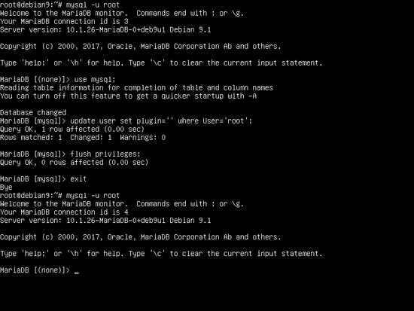

Set root password in MariaDB
In the next step, make sure you secure MariaDB by executing the security script mysql_secure_installation. It is provided by the installation package from Debian repositories. While running the script will ask a series of questions designed to secure MariaDB database. Such as: to change MySQL root password, removing anonymous users, disabling remote root logins, and delete the test database. Execute the script by issuing the below command. Say yes to all questions asked in order to fully secure MySQL daemon. Use the below script output except as a guide.
sudo mysql_secure_installation
NOTE: RUNNING ALL PARTS OF THIS SCRIPT IS RECOMMENDED FOR ALL MariaDB
SERVERS IN PRODUCTION USE! PLEASE READ EACH STEP CAREFULLY!
In order to log into MariaDB to secure it, we'll need the current
password for the root user. If you've just installed MariaDB, and
you haven't set the root password yet, the password will be blank,
so you should just press enter here.
Enter current password for root (enter for none):

OK, successfully used password, moving on...

Setting the root password ensures that nobody can log into the MariaDB
root user without the proper authorisation.

You already have a root password set, so you can safely answer 'n'.

Change the root password? [Y/n] y

New password:

Re-enter new password:

Password updated successfully!

Reloading privilege tables..

... Success!

By default, a MariaDB installation has an anonymous user, allowing anyone
to log into MariaDB without having to have a user account created for
them. This is intended only for testing, and to make the installation
go a bit smoother. You should remove them before moving into a
production environment.

Remove anonymous users? [Y/n] y

... Success!

Normally, root should only be allowed to connect from 'localhost'. This
ensures that someone cannot guess at the root password from the network.
Disallow root login remotely? [Y/n] y

... Success!

By default, MariaDB comes with a database named 'test' that anyone can
access. This is also intended only for testing, and should be removed
before moving into a production environment.
Remove test database and access to it? [Y/n] y
- Dropping test database...
... Success!
- Removing privileges on test database...
... Success!
Reloading the privilege tables will ensure that all changes made so far
will take effect immediately.

Reload privilege tables now? [Y/n] y

... Success!

Cleaning up...

All done! If you've completed all of the above steps, your MariaDB
installation should now be secure.

Thanks for using MariaDB!
Finally, in order to test MariaDB functionality, log in to the database from the console and execute the following command. A list of the default databases should be displayed in the MariaDB console. Leave MariaDB console with exit statement.
mysql -u root –p
MariaDB [(none)]> show databases;
+--------------------+
| Database |
+--------------------+
| information_schema |
| mysql |
| performance_schema |
+--------------------+
3 rows in set (0.00 sec)

MariaDB [(none)]> exit
That’s all! Nginx web server, MariaDB database, and PHP programming language are installed on your Debian 10 machine. You can now start building dynamic websites or web applications for your visitors.
https://vitux.com/debian-nginx-php-mysql-lemp/

How to Install Nginx on Debian 10 Linux
Posted
•
3 min read

Nginx is an open-source, high-performance HTTP and reverse proxy server that powers some of the largest sites on the Internet. Compared to Apache , Nginx can handle a much large number of concurrent connections and has a smaller memory footprint per connection.
Nginx can be used as a standalone web server, and as a reverse proxy for HTTP and non-HTTP servers.
In this tutorial, we’ll explain how to install and manage Nginx on Debian 10 Buster.

Install Nginx
The Nginx package is included in the default Debian Buster repositories. The installation is pretty straightforward, just run the following commands as root or user with sudo privileges :
sudo apt updatesudo apt install nginx
Nginx service will automatically start after the installation process is complete. You can verify it with curl as shown below:

curl -I 127.0.0.1
The output will look similar to this:

HTTP/1.1 200 OK
Server: nginx/1.14.2
Date: Tue, 16 Jul 2019 16:50:46 GMT
Content-Type: text/html
Content-Length: 612
Last-Modified: Tue, 16 Jul 2019 16:50:26 GMT
Connection: keep-alive
ETag: "5d2e0052-264"
Accept-Ranges: bytes
You can use the systemctl command to manage the Nginx service , same as any other systemd unit.

Adjust the Firewall
UFW users can open HTTP (80) and HTTPS (443) ports by enabling the ‘Nginx Full’ profile:
sudo ufw allow 'Nginx Full'
If you are using nftables to filter connections to your system, open the necessary ports by issuing the following command:
nft add rule inet filter input tcp dport {80, 443} ct state new,established counter accept

Nginx Configuration File’s Structure and Best Practices
- Nginx configuration files are stored in the /etc/nginx directory.
- The main Nginx configuration file is /etc/nginx/nginx.conf.
- Server block (vhost) configuration files are stored in /etc/nginx/sites-available directory. The configuration files found in this directory are used by Nginx only when linked to the /etc/nginx/sites-enabled directory.
- To activate a server blocks create a symlink (a pointer) from the configuration file in a sites-available directory to the sites-enabled directory.
- To write more maintainable code, it’s a good idea to follow a standard naming convention. For example, if your domain name is mydomain.com then the configuration file should be named /etc/nginx/sites-available/mydomain.com.conf.
- The /etc/nginx/snippets directory contains configuration snippets that can be included in the server block files. If you use repeatable configuration segments then you can refactor those segments into snippets and include the snippet file to the server blocks.
- Nginx log files (access.log and error.log) are located in the /var/log/nginx/ directory. It is recommended to have a different access and error log files for each server block.
- You can set your domain document root directory to any location you want. The most common locations for webroot include:
  - /home/<user_name>/<site_name>
  - /var/www/<site_name>
  - /var/www/html/<site_name>
  - /opt/<site_name>

Conclusion
Installing Nginx on Debian 10 is a matter of running a single command.
Now that you have installed Nginx on your Debian 10 Linux you can to start deploying your applications and use Nginx as a web or proxy server.
If you have any questions or feedback, feel free to leave a comment.
https://linuxize.com/post/how-to-install-nginx-on-debian-10/

How to Install LEMP on Debian 10 Server
Aaron Kili Categories Debian 4 Comments


A “LEMP” stack is a mixture of open-source software that is typically installed on a Linux server to deploy dynamic applications. This term is an acronym that represents the Linux operating system, Nginx web server, a MariaDB database, and PHP programming.
Read Also: How to Install LAMP on Debian 10 Server
Although this “LEMP” stack normally contains MySQL as the database management system, some Linux distributions such as Debian — use MariaDB as a drop-in replacement for MySQL.

Requirements
- How to Install a Debian 10 (Buster) Minimal Server
In this article, we will explain to you how to install and setup a LEMP environment on a Debian 10 server, using MariaDB as the database management platform.

Installing Nginx Web Server on Debian 10
Nginx is an open-source and cross-platform, lightweight yet powerful and easy to configure HTTP and reverse proxy server, a mail proxy server, and a generic TCP/UDP proxy server, with a modular architecture.
Some of its basic features include serving static and index files; accelerated support with caching of FastCGI, uwsgi, SCGI, and Memcached servers, load balancing and fault tolerance, SSL and TLS SNI support, support for HTTP/2 with weighted and dependency-based prioritization.
To install the Nginx package, use Debian’s apt package manager as shown.
# apt update
# apt install nginx
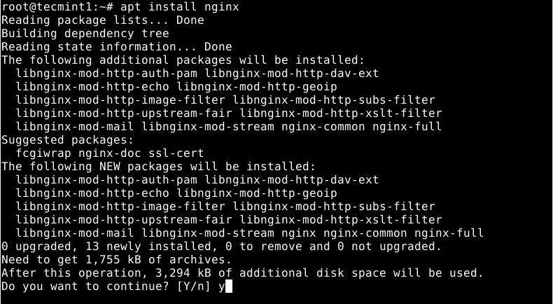
Once the Nginx installation is complete, the installer will activate systemd to start the Nginx service for now and enable it to automatically start at system boot. You can check the status of Nginx using the following systemctl command.
# systemctl status nginx
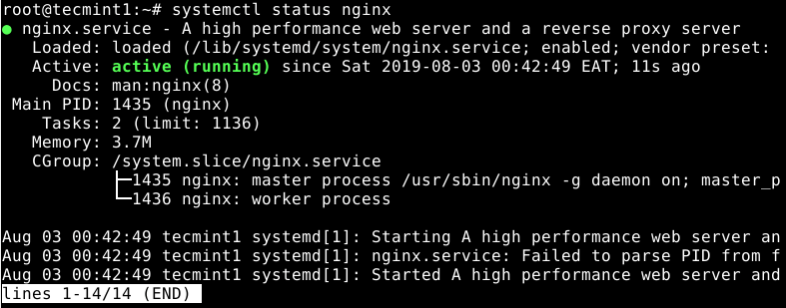
You can also use the following important commands to start, restart, stop, and reload the configuration of the Nginx service under systemd.
# systemctl start nginx
# systemctl restart nginx
# systemctl stop nginx
# systemctl reload nginx
# systemctl status nginx
Next, if you have the UFW firewall running (it is usually disabled by default), you need to open port 80 (HTTP) and 443 (HTTPS) to allow incoming traffic on Nginx.
# ufw allow 80
# ufw allow 443
# ufw status
At this point, you need to test if Nginx is properly installed, whether it is running and can serve web pages. To do that, open a web browser and point it to the following URL to access the Nginx Debian Default web page.
http://SERVER_IP/
OR
http://localhost/
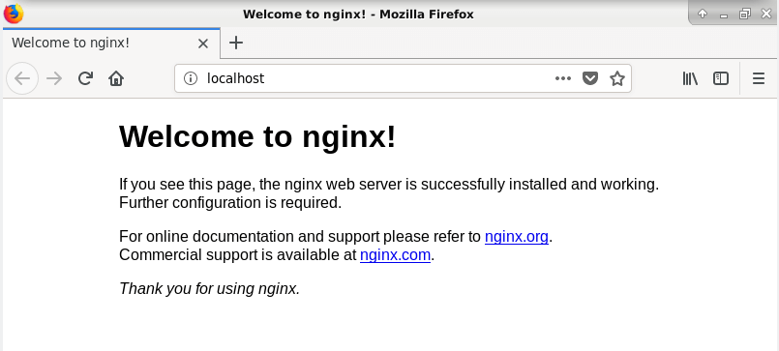

Installing MariaDB on Debian 10
Next, you need to install a database system to be able to store and manage data for your website or web app. Debian 10 supports MariaDB by default, as a drop-in replacement for MySQL.
To install MariaDB, run the following command.
# apt install mariadb-server
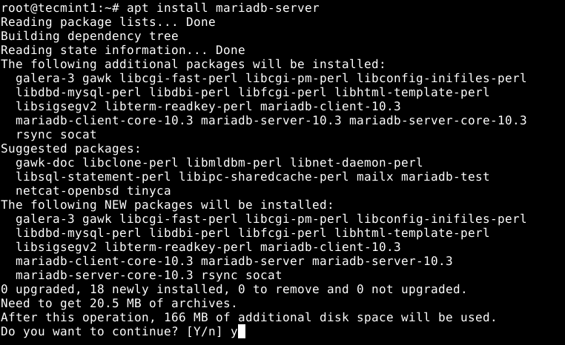
Next, check the MariaDB service status since it is auto started by systemd and enabled to start at system boot, to ensure that it is up and running, use the following command.
# systemctl status mariadb
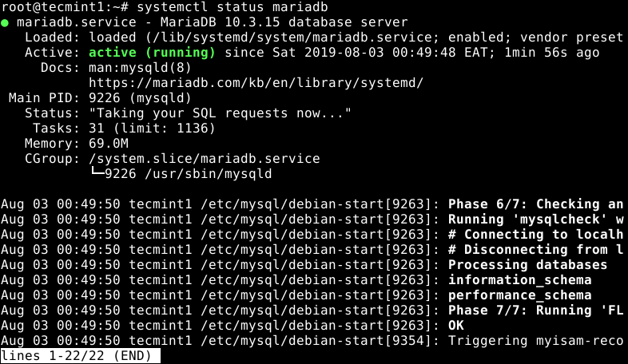
To manage (start, restart, stop and reload) the MariaDB service under systemd, you can use the following command.
# systemctl start mariadb
# systemctl restart mariadb
# systemctl stop mariadb
# systemctl reload mariadb
Next, the MariaDB deployment will be insecure by default. You need to run a shell script which ships in with the package, to enable you to improve the database security.
# mysql_secure_installation
After running the script, it will take you through a series of following questions to modify the default settings of the MariaDB installation as shown in the following screenshot.
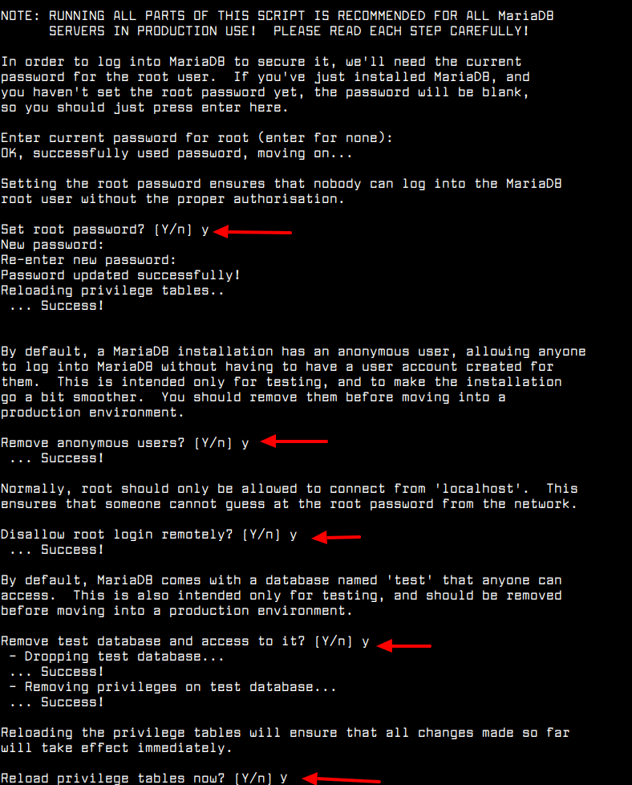

Installing PHP-FPM (Fast Process Manager) on Debian 10
Unlike Apache and other web servers, Nginx does not provide native support for PHP, as it uses PHP-FPM to handle requests for PHP pages. PHP-FPM is an alternative FastCGI daemon for PHP that allows a website to handle high loads, by using worker processes to handle requests.
To install PHP-FPM version 7.3 and a PHP module to communicate with a MariaDB/MySQL database system, run the following command.
# apt install php-fpm php-mysqli
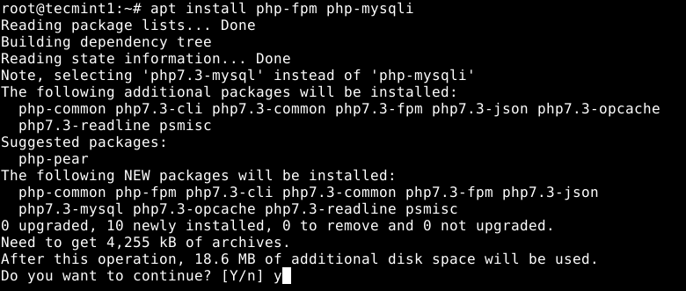
After PHP-FPM is installed, the installer will activate systemd to start the PHP-FPM service for now and enable it to auto-start at system boot. To check if it is up and running, issue the following command.
# systemctl status php-fpm
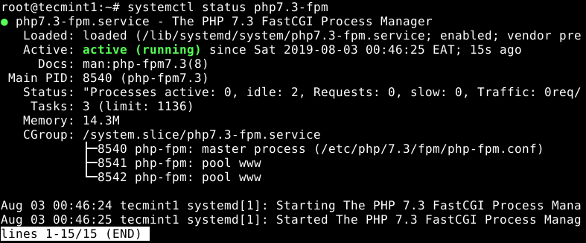
You can also start, restart stop, and reload the configuration of the PHP-FPM service under systemd, as follows.
# systemctl start php-fpm
# systemctl restart php-fpm
# systemctl stop php-fpm
# systemctl reload php-fpm
# systemctl status php-fpm
Next, you need to secure PHP-FPM by making some changes in the configuration file /etc/php/7.3/fpm/php.ini as follows.
# vi /etc/php/7.3/fpm/php.ini
Look for the ;cgi.fix_pathinfo=1 uncomment it by removing the ; character at the start, set its value to 0. This prevents Nginx from allowing non-PHP files to be executed as PHP.
cgi.fix_pathinfo=0
By default, PHP-FPM is configured to listen on a UNIX soxket, /run/php/php7.3-fpm.sock as defined in the /etc/php/7.3/fpm/pool.d/www.conf configuration file. You have to configure all your server block (or virtual hosts) to use this socket if they are to process and serve PHP pages.
You can use the Nginx default server block configuration file /etc/nginx/sites-available/default to test it.
# vi /etc/nginx/sites-available/default
Look for the following section and uncomment it to pass PHP scripts to FastCGI server as shown in the screenshot.
location ~ \.php$ {
include snippets/fastcgi-php.conf;
fastcgi_pass unix:/run/php/php7.3-fpm.sock;
}
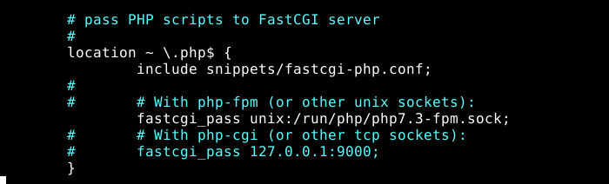
Next, test if the Nginx configuration structure is OK, using the following command.
# nginx -t
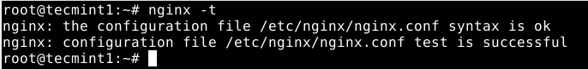
If the Nginx configuration is OK, to apply the recently made changes, restart the php7.3-fpm and nginx services as follows.
# systemctl restart php7.2-fpm
# systemctl restart nginx

Testing PHP-FPM Processing on Nginx
After configuring PHP-FPM and Nginx to work together, you need to test if two services can process and serve PHP pages to clients. To do that, create a simple PHP script in your web DocumentRoot as follows.
# echo “<?php phpinfo(); ?>” | tee /var/www/html/info.php
Finally, open a browser and type the following address to see the PHP configurations on the system as generated by the phpinfo() function.
http://SERVER_IP/info.php
OR
http://localhost/info.php
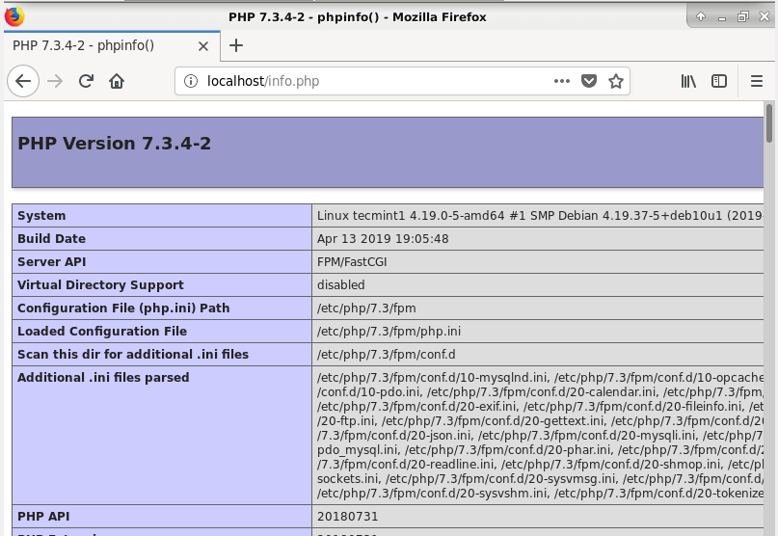

Conclusion
In this article, we have shown how to install and configure the LEMP stack in Debian 10. If you’ve got any questions or feedback, please reach out and let us know via the comment form below.
https://www.tecmint.com/install-lemp-on-debian-10-server/

How To Install PHP 7.4 on Debian 10 / Debian 9
By
Josphat Mutai
-
143662
0
You can support us by downloading this article as PDF from the Link below. Download the guide as PDF
How can I install PHP 7.4 on Debian 10 (Buster) / Debian 9 (Stretch)?. PHP is the most widely used server-side scripting language in creation of dynamic web pages. PHP applications usually work well with HTML and interact with relation database management systems. With each release of PHP, there are plethora of new features.
This installation of PHP 7.4 on Debian 10 / Debian 9 is available for production use. The GA release was made public on November 28, 2019. It is not recommended to run beta release in Production. It should be used for testing new features in PHP 7.4 and preparation for deprecated features.



Install PHP 7.4 on Debian 10 / Debian 9
Follow the steps covered below to install PHP 7.4 on Debian 10 & Debian 9 Linux distribution. The latest builds of PHP for Debian are available on SURY PHP PPA repository. We’ll add the repository as prerequisite then install PHP 7.4 on Debian 10 / Debian 9 from it.

Step 1: Update system
Ensure your system is updated:
sudo apt update
sudo apt upgrade -y && sudo reboot

Step 2: Add SURY PHP PPA repository
Download and store PPA repository in a file on your Debian Server/Desktop. But first, download GPG key.
sudo apt -y install lsb-release apt-transport-https ca-certificates
sudo wget -O /etc/apt/trusted.gpg.d/php.gpg https://packages.sury.org/php/apt.gpg
Then add repository.
echo "deb https://packages.sury.org/php/ $(lsb_release -sc) main" | sudo tee /etc/apt/sources.list.d/php.list

Step 3: Install PHP 7.4 on Debian 10 / Debian 9
The last step is to Install PHP 7.4 on Debian 10 / Debian 9. Before installation, update system package list on added repositories.
sudo apt update
Then install PHP 7.4 on Debian 10 / Debian 9:
sudo apt -y install php7.4
Answer yes when prompted to complete installation of PHP 7.4 on Debian 10 / Debian 9 Linux system.
Reading package lists... Done
Building dependency tree
Reading state information... Done
The following additional packages will be installed:
apache2 apache2-bin apache2-data apache2-utils libapache2-mod-php7.4 libapr1 libaprutil1 libaprutil1-dbd-sqlite3 libaprutil1-ldap libbrotli1
libcurl4 libgdbm-compat4 libgdbm6 libjansson4 libldap-2.4-2 libldap-common liblua5.2-0 libnghttp2-14 libpcre2-8-0 libperl5.28 librtmp1
libsasl2-2 libsasl2-modules libsasl2-modules-db libsodium23 libssh2-1 perl perl-modules-5.28 php-common php7.4-cli php7.4-common php7.4-json
php7.4-opcache php7.4-readline psmisc ssl-cert
Suggested packages:
apache2-doc apache2-suexec-pristine | apache2-suexec-custom www-browser php-pear libsasl2-modules-gssapi-mit | libsasl2-modules-gssapi-heimdal
libsasl2-modules-ldap libsasl2-modules-otp libsasl2-modules-sql perl-doc libterm-readline-gnu-perl | libterm-readline-perl-perl make
libb-debug-perl liblocale-codes-perl openssl-blacklist
The following NEW packages will be installed:
apache2 apache2-bin apache2-data apache2-utils libapache2-mod-php7.4 libapr1 libaprutil1 libaprutil1-dbd-sqlite3 libaprutil1-ldap libbrotli1
libcurl4 libgdbm-compat4 libgdbm6 libjansson4 libldap-2.4-2 libldap-common liblua5.2-0 libnghttp2-14 libperl5.28 librtmp1 libsasl2-2
libsasl2-modules libsasl2-modules-db libsodium23 libssh2-1 perl perl-modules-5.28 php-common php7.4 php7.4-cli php7.4-common php7.4-json
php7.4-opcache php7.4-readline psmisc ssl-cert
The following packages will be upgraded:
libpcre2-8-0
1 upgraded, 36 newly installed, 0 to remove and 7 not upgraded.
Need to get 15.0 MB of archives.
After this operation, 76.9 MB of additional disk space will be used.
Do you want to continue? [Y/n] y
Use the next command to install additional packages:
sudo apt-get install php7.4-xxx
Example:
sudo apt-get install php7.4-{bcmath,bz2,intl,gd,mbstring,mysql,zip}
PHP configurations related to Apache is stored in /etc/php/7.4/apache2/php.ini

Using PHP with Nginx:
The installation of php on Debian configures Apache. For users interested in running Nginx and PHP, you need to stop and disable Apache service.
sudo systemctl disable --now apache2
Then install fpm extension and nginx packages.
sudo apt-get install nginx php7.4-fpm
PHP FPM configuration files are located in the directory: /etc/php/7.4/fpm/
The nginx and php-fpm services should be running.
$ systemctl status php7.4-fpm nginx
● php7.4-fpm.service - The PHP 7.4 FastCGI Process Manager
Loaded: loaded (/lib/systemd/system/php7.4-fpm.service; enabled; vendor preset: enabled)
Active: active (running) since Thu 2019-09-19 17:32:26 UTC; 14s ago
Docs: man:php-fpm7.4(8)
Main PID: 12151 (php-fpm7.4)
Status: "Processes active: 0, idle: 2, Requests: 0, slow: 0, Traffic: 0req/sec"
Tasks: 3 (limit: 2377)
Memory: 14.7M
CGroup: /system.slice/php7.4-fpm.service
├─12151 php-fpm: master process (/etc/php/7.4/fpm/php-fpm.conf)
├─12152 php-fpm: pool www
└─12153 php-fpm: pool www

Sep 19 17:32:26 deb10 systemd[1]: Starting The PHP 7.4 FastCGI Process Manager...
Sep 19 17:32:26 deb10 systemd[1]: Started The PHP 7.4 FastCGI Process Manager.

● nginx.service - A high performance web server and a reverse proxy server
Loaded: loaded (/lib/systemd/system/nginx.service; enabled; vendor preset: enabled)
Active: active (running) since Thu 2019-09-19 17:32:27 UTC; 12s ago
Docs: man:nginx(8)
Main PID: 12362 (nginx)
Tasks: 2 (limit: 2377)
Memory: 3.2M
CGroup: /system.slice/nginx.service
├─12362 nginx: master process /usr/sbin/nginx -g daemon on; master_process on;
└─12363 nginx: worker process

Sep 19 17:32:27 deb10 systemd[1]: Starting A high performance web server and a reverse proxy server...
Sep 19 17:32:27 deb10 systemd[1]: nginx.service: Failed to parse PID from file /run/nginx.pid: Invalid argument
Sep 19 17:32:27 deb10 systemd[1]: Started A high performance web server and a reverse proxy server.
Enjoy your websites and Web Applications development with PHP 7.4 on Debian 10 / Debian 9 Linux system.
https://computingforgeeks.com/how-to-install-latest-php-on-debian/

